Dan Forbush, J.D. Van Slyke, Austin Zamudio

May 3, 2019

PA 541 - Advanced Data Analysis

State Politics, Control & Debt

**Introduction**

It has become a popular narrative in modern politics that Republicans are the party of fiscal responsibility and that Democrats propose spending program that they cannot pay for. This narrative has been combined with increasing concern about the amount of debt that state governments are relying upon to finance budget deficits. Taken together, these two narratives should show up robustly in state government budget data, with states controlled by Republicans issuing less debt to finance expenditures than states that are controlled by Democrats. In this paper, using data collected by the United States Census Bureau about state and local government finances, we seek to analyze empirically whether the parties lived up to this narrative during 2016.

**Background**

“Debt: The shame of cities and states,” identifies the historic factors that played a role in shaping the debt crisis of multiple states, particularly public employee pensions and health care (Keller, 2011). Previously viewed as a scarcely used extra bonus for public employees, the language in regard to these expenditures has now shifted towards “entitlements,” largely due to political and governmental context. Collective bargaining from unions shifted power and political clout to public sector employees, granting them health and pension benefits. In the wake of these victories, however, a number of fiscal crises rocked the foundation of the finances of multiple states.

Keller calls upon the work of James Madison to state, “that public policy was best served by a broad rather than narrow spectrum of competing interests; and that political compromises emerging from the interplay of interests and the facts on the ground was the best route to a viable resolution” (Keller, 2011). The author then identifies a number of conflicts between various stakeholders in the battle for fiscal stability, as well as how different parties respond to fiscal crisis. Political culture, economic situation, and leaderships all contribute to state response to debt (Keller, 2011). Furthermore, Republican controlled states call for less union autonomy, and more constraints on entitlements.

In addition to health and pension expenses, capital projects are also viewed as one of the main contributing factors to state debt. The article by Yan (2013) examines the impact revenue volatility has on how much a state borrows to fund capital projects, specifically infrastructure development. A topic noted by Yan that is later noted by Alt and Lowry (2001) is the impact of interest payments. Revenue volatility can negatively impact a state’s ability to make timely interest payments, furthering the state’s long-term debt. In public finance, revenue diversification and financial reserves help combat uncertainty. Capital projects are paid off over time through long-term debt, which also furthers intergenerational equity by ensuring one generation is not stuck with the large bill of a previous. This method is attributed to the “Golden Rule” of public finance – “current services should be paid with current revenues” (Yan, 2013).

Relative to the group’s analysis is the role politics plays in debt financing. Capital projects are more subject to voter preferences than day-to-day expenses. In times of financial crisis, capital projects are more likely to be postponed than daily operations. Furthermore, “it is politically and technically more feasible to make such cuts because the benefits of capital projects are usually long-term and less apparent than those of current services” (Yan, 2013). States with more economic instability are more likely to use debt financing to pay for a project throughout its lifetime.

The article by Alt and Lowry (2001) explains the impact government, legal restrictions, and partisan preferences have on state debt payments. The authors hypothesize, “that when Democrats (the party representing those with a ‘high demand’ for public spending and taxing) have unified control of state government and run deficits due to economic shocks, they are slower and less certain to restore fiscal balance” (Alt, Lowry, 2001). As a result, it is expected that investors impose higher interest rates during periods of Democratically controlled deficit. On the opposite end of the spectrum, Republicans are viewed by the public as the more fiscally conservative party. Since both parties have their own image of what the ideal level of state spending is, fiscal policy would be negatively impacted in times of divided government. Divided government complicates the ability to resolve fiscal crisis due to the delicate process of navigating the oftentimes mutually exclusive preferences of the two polarized parties. Investors seeking to take advantage of this roadblock in a split state government are expected impose higher interest rates, thus leading to lengthier state debt.

To test their hypotheses, the authors run a generalized least squares model that includes total state debt, state per capita income, the state unemployment rate, bond ratings, strictness of fiscal legislation, deficit, and partisan control among other variables. Interaction effects are present for some variables as well. Unified Democratic government is interacted with a lagged deficit and has a positive significant coefficient, meaning investors view Democratic deficit more negatively, translating into costly interest payments. Split control is interacted with a lagged deficit and it isn’t significant, however this is due to scarce data and outliers. The data suggests that investors are more likely to impose higher interest payments on “high demand parties” (Democrats), but the data on imposing higher rates on split control state governments is inconclusive (Alt, Lowry, 2011).

Buschman and Sjoquist (2017) seek to examine the impact short-term fiscal conditions have on legislative tax changes. The authors build on previous work done by Alt and Lowry but focus more specifically on the impact of budget gaps, be it deficit or surplus. Public institutions are not out to seek a profit, and by nature, balance is the gold standard within government finance. Bushman and Sjoquist (2017) hypothesize that the larger the deficit (surplus), the larger the tax increase (decrease). Furthermore, tax changes will be larger for surpluses than deficits. The key component in their model relative to the team’s analysis of state finance is the political party in control of the state government. The authors anticipate that in times of negative financial conditions (deficit), Republicans prefer a larger expenditure cut and smaller tax increase than Democrats (Bushman, Sjoquist, 2017).

The Republican (GOP) and Democrat (DEM) explanatory variables were interacted with BUDGETGAP. Without the interaction term for both variables, tax increases are smaller for Republicans and larger for Democrats than they would be if the government was split. With the interaction term of BUDGETGAP, only GOP*BUDGETGAP is significant. The data disproves the previously mentioned hypothesis and suggests instead that unified government, regardless of party control, “magnifies the tax policy response to negative shocks” (Bushman, Sjoquist, 2017). While not an inherent cause of state debt, the data highlights budget implications moving forward in regard to state party ability to resolve debt.

**Research Question and Hypotheses**

Given the amount of attention being paid to debt financing of state and local governments and the different stances of the two major political parties on this issue, our main research interest is to explore how political control at the state level affects debt financing. For the year 2016, we compare state governments where power was unified in control by Democrats, unified in control by Republicans, and split between the parties, such as when the governor was a Democrat and one chamber of the legislature was Republican. We also explore whether states with split governments take on less debt than states where power was unified, possibly because the conflicting ideologies reduced expenditures financed by debt due to disagreements between the parties.

Based on the literature and our research questions, we formed three hypotheses:

*H1: State legislatures with chambers controlled by different political parties will have lower levels of debt financing.*

*H2: States with split governments (where the Governor’s political party does not match the political party controlling the state legislature) will have lower levels of debt financing.*

The reasoning behind these first two hypotheses comes from the idea that Republicans or Democrats, when in control of the legislature, will be more unified in the projects they want to pursue, be it in the form of tax cuts or different increased expenditures. Therefore, they will take on more debt to pay for those projects, which may be different in nature.

*H3: States controlled by Democrats will take on more debt than states controlled by Republicans.*

The reasoning behind this last hypothesis follows from the Alt and Lowry (2001) article, where they identify Democrats as the “high-demand” party and thus more likely to take on larger expenditures to finance larger government projects, while Republicans have a preference for reduced expenditures to match more with their preference for lower taxes. If this theory is true, we should see higher levels of debt issued in Democratic states.

**Dataset and Model**

Our primary data source is the 2016 State & Local Government Finance Historical Datasets and Tables collected by the Census Bureau. This annual survey collects detailed information about state and local finances and divides into numerous categories for both revenue and expenditures. Per the dataset’s methodology documentation, the data is collected based on a legal mandate and is done by surveying state and local governments to report their revenue and expenditures for their prior fiscal year that ends between July 1, 2015 through June 30, 2016. So, if a state’s fiscal year ends on December 31, 2015, they would report financial data for the fiscal year lasting between January 1, 2015 and December 31, 2015.

For our research, we focused only on state-level data and we excluded the District of Columbia. To control for the differences in issues faced by different regions around the country, we classified states by regions based off how the Census Bureau defines regions in the United States. Furthermore, we included the Census Bureau estimate of population in the different states in 2016. Though population was not used in our models, it was used to calculate per-capita statistics compiled below. Finally, we incorporated data about legislative, governor, and state party control as compiled by the National Conference of State Legislatures.

Our primary dependent variable is the amount of long-term debt states issued in a given fiscal year. According to the Census Bureau’s Government Finance and Employment Classification Manual, this includes a wide variety of debt that is due more than one year from its issue date, including General Obligation Bonds and a variety of specific bonds, and it excludes leases and other expenditures like unfunded pension liabilities. For our independent variables, we looked at two types expenditures: first, capital expenditure, based on the general practice in public finance that debt spending finances capital projects; and second, a sum of the state’s spending on pension, wages/salaries, and health (hereafter called “specific expenditures”), based on the variables that Keller (2011) identified as exacerbating state debt spending.

The nature of the variables in the dataset are prone to multicollinearity when used together in a linear regression model. If one variable increases, such as a certain expenditure, then all the other variables will increase linearly as well. Likewise, the variables in the dataset also increase linearly with the state’s population. Therefore, we could only examine one continuous independent variable at a time to see its influence on the dependent variable, and we used a log-log model that roughly approximates percentage increases to account for state population size. To test our hypotheses, we looked to see to what extent party political control acted as a moderator between these two variables. A graphical representation of this model is shown in Figure 1:

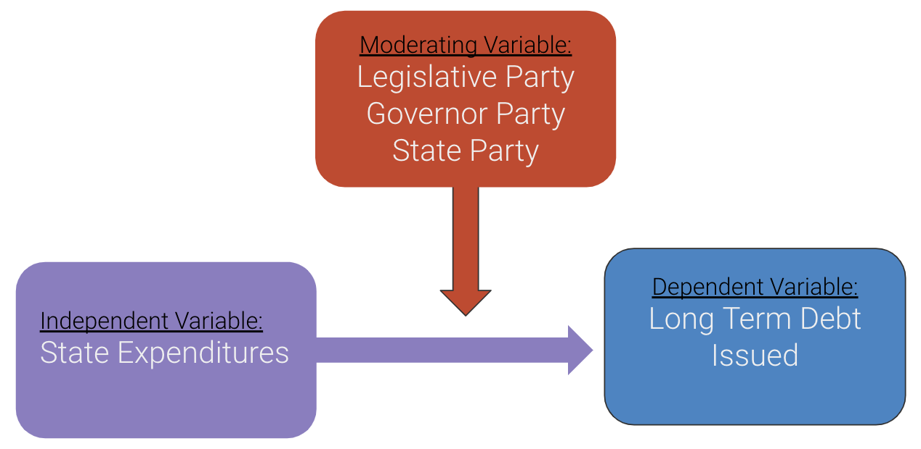

*Figure 1 - Graphical Representation of Linear Regression Analysis Model*

**Results**

When looking at the dependent variable, Long Term Debt Issued, at a per-capita level, there is evidence that Republican-controlled states issue less debt at all levels of control, as is shown in Tables 1 - 3:

|  |  |  |  |  |  |  |
| --- | --- | --- | --- | --- | --- | --- |
| *Table 1 - Long Term Debt Issued Per-Capita Grouped by Legislature Control*  *(dollar amounts are in thousands)* | | | | | | |
| **Legislature Party** | **N** | **Mean ($)** | **SD ($)** | **Min ($)** | **Max ($)** | **Median ($)** |
| Democratic Control | 11 | .8009 | .4351 | .3296 | 1.528 | .6223 |
| Republican Control | 30 | .4096 | .3293 | .1038 | 1.4691 | .2549 |
| Split Control | 8 | .5778 | .2433 | .1615 | .9789 | .5636 |

|  |  |  |  |  |  |  |
| --- | --- | --- | --- | --- | --- | --- |
| *Table 2 - Long Term Debt Issued Per-Capita Grouped by State Governor Party*  *(dollar amounts are in thousands)* | | | | | | |
| **Governor Party** | **N** | **Mean ($)** | **SD ($)** | **Min ($)** | **Max ($)** | **Median ($)** |
| Democratic Governor | 17 | .6654 | .4137 | .1530 | 1.5277 | .5410 |
| Republican Governor | 32 | .4200 | .3128 | .1038 | 1.4691 | .3061 |
| Independent Governor | 1 | 1.1388 | NA | 1.1388 | 1.1388 | 1.1388 |

|  |  |  |  |  |  |  |
| --- | --- | --- | --- | --- | --- | --- |
| *Table 3 - Long Term Debt Issued Per-Capita Grouped by State Party Control*  *(dollar amounts are in thousands)* | | | | | | |
| **State Party** | **N** | **Mean ($)** | **SD ($)** | **Min ($)** | **Max ($)** | **Median ($)** |
| Democratic States | 7 | .8756 | .5004 | .3295 | 1.5277 | .6504 |
| Republican States | 23 | .3747 | .3149 | .1038 | 1.4691 | .2426 |
| Split States | 19 | .5775 | .2977 | .1530 | 1.1388 | .5106 |

Both the mean and the median per-capita long term debt issued is less in Republican states than in Democrat states, and that is true at the legislative, governor, and state levels. Additionally, for all categories of political power - whether it is controlled by Democrats, Republicans, or split - the mean is greater than median, suggesting that high-debt states skew the mean in each category. It is notable how many more levels of politics were controlled by Republicans than Democrats in 2016, with Democrats only controlling 7 states at every level of government. It should also be noted that there is one Independent governor, in Alaska, and that another state, Nebraska, has a unicameral and nonpartisan legislature, so it is not counted in Table 1 or Table 3. These states show up as unique results in our models.

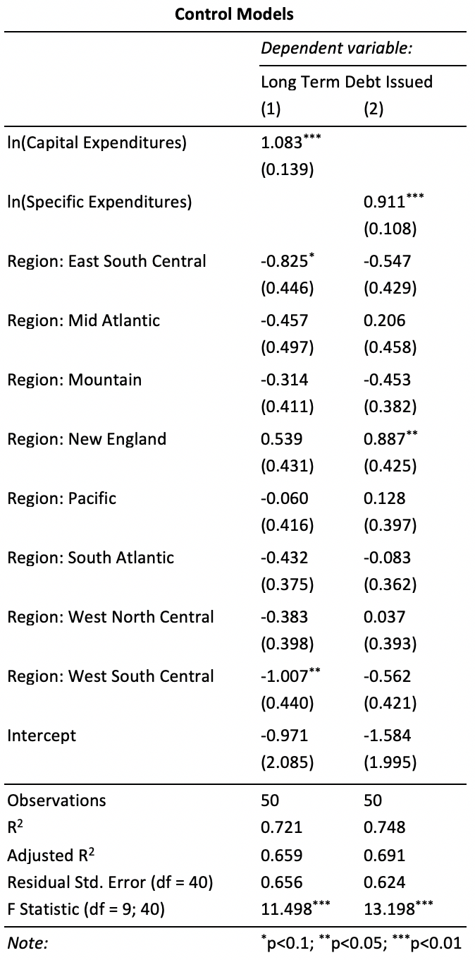

*Figure 2 - Results of Control Models Without Any Moderating Variables. Model (1) shows the influence of Capital Expenditures on Long Term Debt Issued, and Model (2) shows the influence of Specific Expenditures on Long Term Debt Issued.*

The results of the control models, without any moderating variables that examine the influence of political party control, are presented in Figure 2. Capital expenditure has a stronger correlation than the specific expenditures - a 1% increase in capital expenditures is associated with a 1.08% increase in long term debt issued, as compared with .91% for specific expenditures. Regional effects are also shown, with regions in the south generally issuing less debt than in New England.

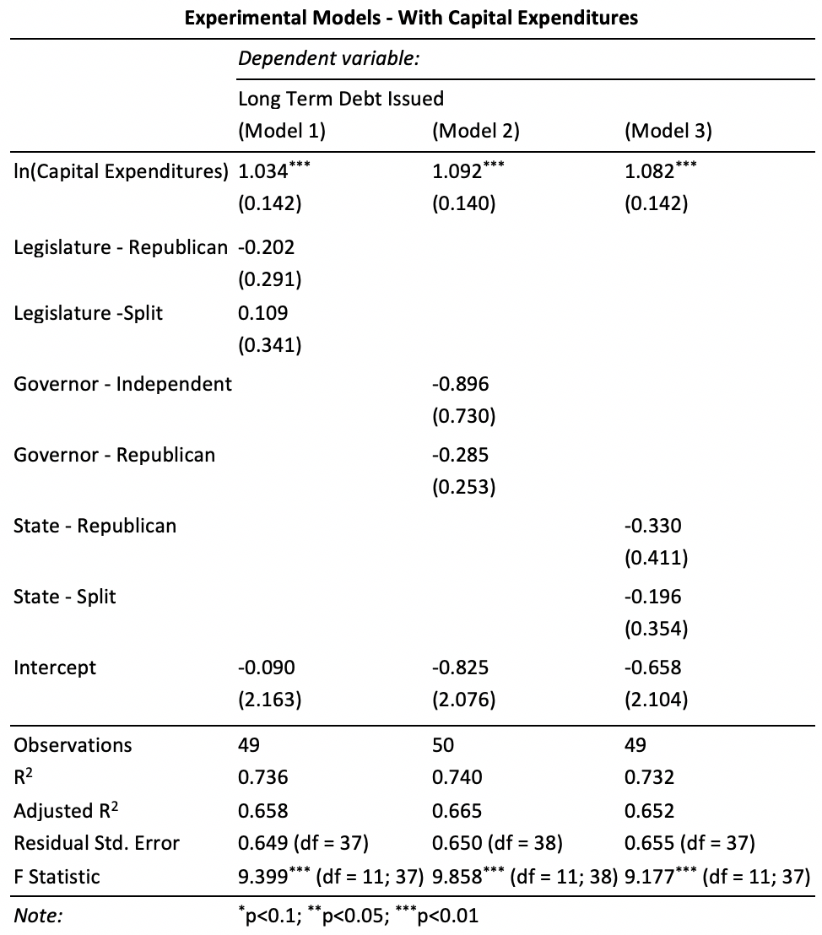

*Figure 3 - Models Examining Moderating Influence of Legislature Control (Model 1), Governor Party (Model 2), and State Control (Model 3) on Capital Expenditures as a Predictor of Long-Term Debt Issued. Base models are Democrat-controlled states. Region was used as a control variable in the model calculations, but the results are not displayed in this figure.*

Figure 3 shows the results of the first set of models testing our hypotheses. In general, with each percentage increase in capital expenditure, Republican-controlled legislatures and Republican-controlled states issue .20% and .33% less debt, respectively, than Democratic states. Split states are in the middle between Republican-controlled and Democratic-controlled states. Likewise, with each percentage increase in capital expenditure, Republican governors issue .29% less debt than Democratic governors. However, none of these results are statistically significant at any level.

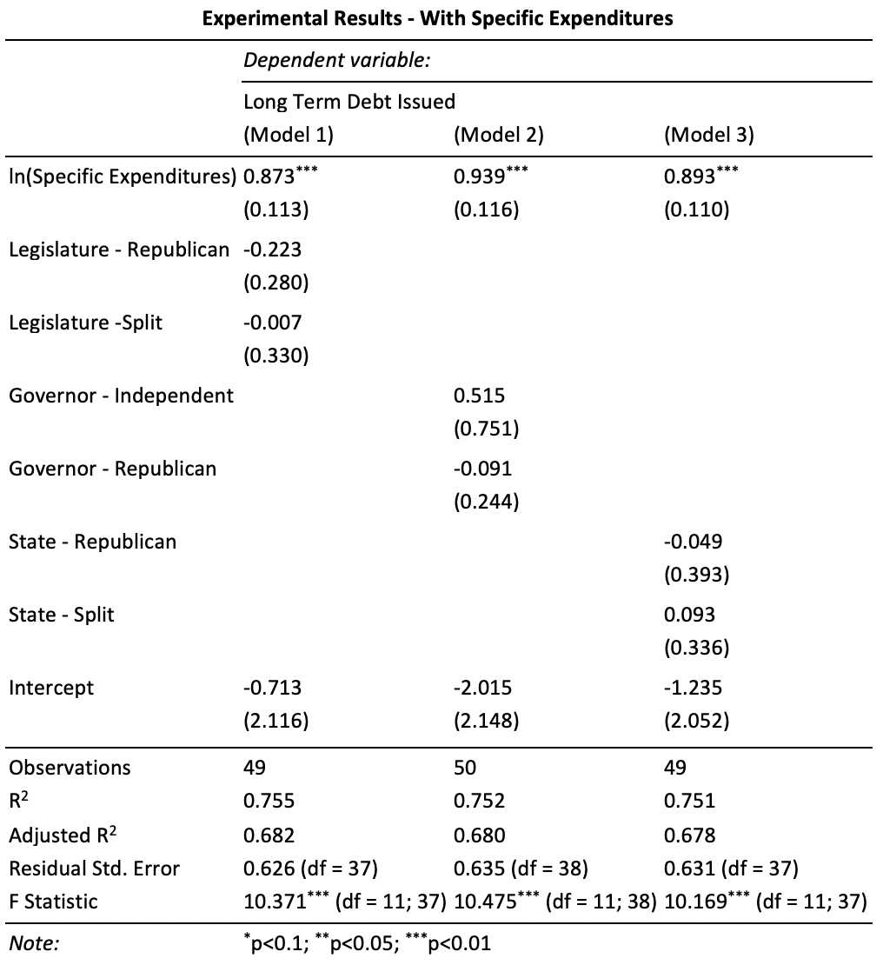

*Figure 4 - Models Examining Moderating Influence of Legislature Control (Model 1), Governor Party (Model 2), and State Control (Model 3) on Specific Expenditures as a Predictor of Long-Term Debt Issued. Base models are Democrat-controlled states. Region was used as a control variable in the model calculations, but the results are not displayed in this figure.*

The corresponding results for the moderating influence of legislative, governor, and state control on the relationship between specific expenditures and long-term debt issued are summarized in Figure 4. Political party control overall has less of a moderating influence on this relationship, with the Republican-controlled legislatures, governors, and states issuing .223%, .091%, and .049% less debt, respectively, with each percentage point increase in specific expenditures. These results are still generally consistent with the models in Figure 3, though they are also not statistically significant at any level.

A graphical representation of the regressions is displayed in Figure 5, with 5A corresponding with the models in Figure 3 and 5B corresponding with the models in Figure 4. Results of model assumption testing, which confirm no issues with multicollinearity and heteroskedasticity in our models, are contained in the Appendix.

*A.*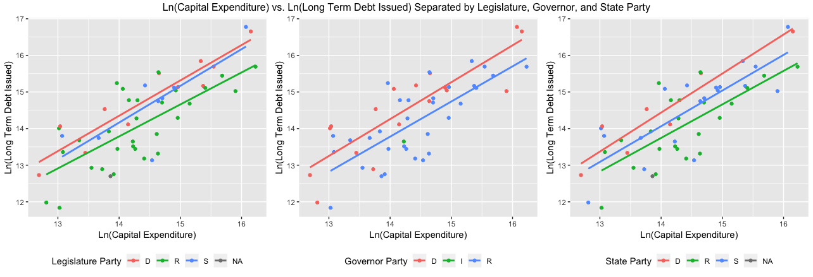

*B.*

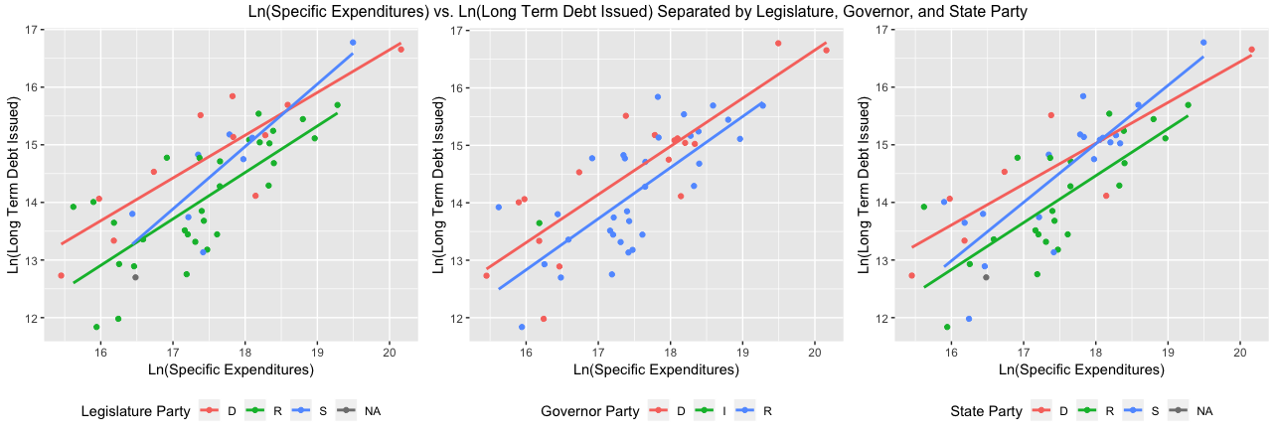

*Figure 5 - Graphical Representation of Log-Log Models, with (A) corresponding to the models in Figure 3 and (B) corresponding with the models in Figure 4.*

**Discussion**

In general, the results are consistent in showing that the Republican-controlled states issue less debt than Democratic-controlled states. These results do not show that unified states, regardless of which party is in control, issues more debt than split states, either due to a split in power between the governor and the legislature or where one party controls one chamber of the legislature and the other party control the other chamber. Therefore, our results provide support for our hypothesis H3 and do not necessarily support our hypotheses H1 and H2.

However, none of the results on our moderating variables are statistically significant at any level; therefore, we cannot reject the null hypothesis that there is no moderating influence on the relationship between capital expenditures or specific expenditures and long-term debt issued. Thus, we cannot say with statistical certainty that any of the relationships we observe in the analysis are not due to chance and are in fact due to an underlying difference in states controlled by one party or states where power is split. Additionally, we cannot say with statistical certainty that split states issue less debt than unified states.

Our analysis does face certain limitations. The limitations in our data - because we can only examine the influence on the dependent variable of one independent variable at time - mean we are susceptible to omitted variable bias. Additional expenditures or factors not included in our model may moderate the relationship between our independent and dependent variable. Additionally, this analysis only examines data for one year and does not take into account a state’s political history. It is also unclear whether the relationship between our independent variable and dependent variable is truly linear. Finally, our sample size is small by necessity, because there are only 50 states, and that may influence the calculations related to statistical significance.

**Conclusion**

Our analysis provides weak support, at best, for the popular narrative that Republican states issue less long-term debt and therefore rely less on debt financing. The fact that the support for this narrative is not more pronounced may itself be more significant than the weak relationship our analysis has shown. Such an interpretation may suggest that other influences and factors than political party control may influence a state’s fiscal condition in regard to the debt it issues.

Future studies should seek to combine data across a period of years and examine potential fixed effects and the difference that changing political control makes in the amount of long-term debt issued. Additionally, future models can incorporate additional data to remove the possible influence of omitted variables.

**Works Cited**

Buschman, R. D., & Sjoquist, D. L. (2017). An Exploration of Differential State Responses to Changes in Fiscal Conditions. Public Budgeting & Finance, 37(1), 47–67. <https://doi-org.proxy.cc.uic.edu/10.1111/pbaf.12150>

Keller, M. (2011). Debt: The shame of cities and states. Policy Review, (169) Retrieved from <http://proxy.cc.uic.edu/login?url=https://search-proquest-com.proxy.cc.uic.edu/docview/964243880?accountid=14552>

Lowry, R. C., & Alt, J. E. (2001). A Visible Hand? Bond Markets, Political Parties, Balanced Budget Laws, And State Government Debt. Economics & Politics, 13(1), 49. Retrieved from <http://search.ebscohost.com.proxy.cc.uic.edu/login.aspx?direct=true&db=buh&AN=5014704>

National Conference of State Legislatures. (2016). 2016 State and Legislative Party Composition. Retrieved from <http://www.ncsl.org/portals/1/documents/elections/Legis_Control_2016.pdf>

United States Census Bureau. (2006). Government Finance and Employment Classification Manual. Retrieved from <https://www2.census.gov/govs/pubs/classification/2006_classification_manual.pdf>

United States Census Bureau. (2010). 2010 Census Regions and Divisions of the United States. Retrieved from <https://www2.census.gov/geo/docs/maps-data/maps/reg_div.txt>

United States Census Bureau. (2016). 2016 State & Local Government Finance Historical Datasets and Tables. Retrieved from <https://www.census.gov/data/datasets/2016/econ/local/public-use-datasets.html>

United States Census Bureau. (2016) Table 1. Annual Estimates of the Resident Population for the United States, Regions, States, and Puerto Rico: April 1, 2010 to July 1, 2016. Retrieved from <https://www2.census.gov/programs-surveys/popest/tables/2010-2016/state/totals/nst-est2016-01.xlsx>

Yan, W. (2013). Using trend data to evaluate the differential response of state borrowing to revenue volatility. Public Budgeting & Finance, 33(2), 75-92. doi:<http://dx.doi.org.proxy.cc.uic.edu/10.1111/j.1540-5850.2013.12009.x>

**Appendix**

|  |  |
| --- | --- |
| *Table A1 - Multicollinearity and Heteroskedasticity Results for Control Models from Figure 2* | |
|  | **VIF test results** |
| Model 1 | GVIF Df GVIF^(1/(2*Df))  log(Direct.expend.Capital.outlay) 1.7851 1 1.336076  Region 1.7851 8 1.036881 |
| Model 2 | GVIF Df GVIF^(1/(2*Df))  log(specificspend) 1.572724 1 1.254083  Region 1.572724 8 1.028705 |
|  | **Studentized Breusch-Pagan test results** |
| Model 1 | BP = 14.517, df = 9, p-value = 0.1051 |
| Model 2 | BP = 11.079, df = 9, p-value = 0.2704 |

|  |  |
| --- | --- |
| *Table A2 - Multicollinearity and Heteroskedasticity Results for Control Models from Figure 3* | |
|  | **VIF test results** |
| Model 1 | GVIF Df GVIF^(1/(2*Df))  Region 3.356533 8 1.078619  log(Direct.expend.Capital.outlay) 1.874423 1 1.369096  legisparty 1.905461 2 1.174898 |
| Model 2 | GVIF Df GVIF^(1/(2*Df))  Region 3.675402 8 1.084755  log(Direct.expend.Capital.outlay) 1.853200 1 1.361323  govparty 2.075208 2 1.200233 |
| Model 3 | GVIF Df GVIF^(1/(2*Df))  Region 4.515902 8 1.098807  log(Direct.expend.Capital.outlay) 1.841614 1 1.357061  stateparty 2.637610 2 1.274391 |
|  | **Studentized Breusch-Pagan test results** |
| Model 1 | BP = 14.452, df = 11, p-value = 0.209 |
| Model 2 | BP = 17.033, df = 11, p-value = 0.1069 |
| Model 3 | BP = 12.907, df = 11, p-value = 0.2994 |

|  |  |
| --- | --- |
| *Table A2 - Multicollinearity and Heteroskedasticity Results for Control Models from Figure 4* | |
|  | **VIF test results** |
| Model 1 | GVIF Df GVIF^(1/(2*Df))  Region 2.975736 8 1.070532  log(specificspend) 1.664935 1 1.290323  legisparty 1.935198 2 1.179455 |
| Model 2 | GVIF Df GVIF^(1/(2*Df))  Region 3.414824 8 1.079781  log(specificspend) 1.766657 1 1.329156  govparty 2.245441 2 1.224124 |
| Model 3 | GVIF Df GVIF^(1/(2*Df))  Region 3.918572 8 1.089107  log(specificspend) 1.567160 1 1.251863  stateparty 2.566382 2 1.265699 |
|  | **Studentized Breusch-Pagan test results** |
| Model 1 | BP = 15.805, df = 11, p-value = 0.1485 |
| Model 2 | BP = 14.576, df = 11, p-value = 0.2028 |
| Model 3 | BP = 12.52, df = 11, p-value = 0.3258 |

The highest GVIF value is approximately 4.5, for Region variable in Model 3 of Figure 3. This is below the value of 5, the low-threshold for where multicollinearity might be a concern. Therefore, because this is the highest VIF value for any set of variables in our models, we do not see concern for multicollinearity in our model results.

Similar, the Breusch-Pagan tests all return p-values that are not statistically significant at any acceptable level (including at the .1 level). Thus, heteroskedasticity is not a concern in our models.